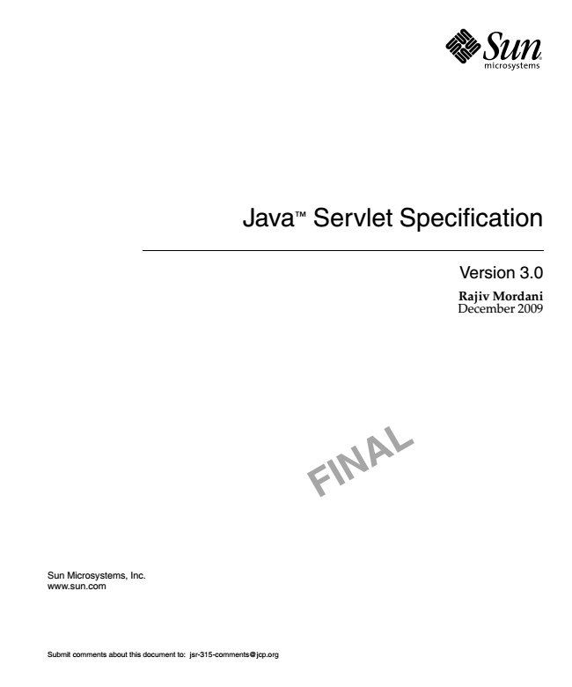

Java

TM

Sun Microsystems, Inc. www.sun.com

Submit comments about this document to: jsr-315-comments@jcp.org

Servlet Specification

Version 3.0

**Rajiv Mordani December 2009**

**F**

**IN**

**A**

**L**

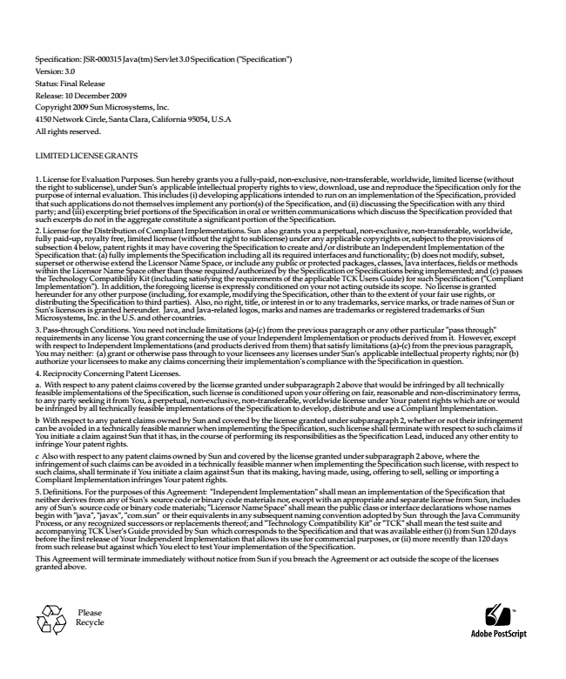

Specification: JSR-000315 Java(tm) Servlet 3.0 Specification ("Specification") Version: 3.0 Status: Final Release Release: 10 December 2009 Copyright 2009 Sun Microsystems, Inc. 4150 Network Circle, Santa Clara, California 95054, U.S.A All rights reserved.

LIMITED LICENSE GRANTS

1. License for Evaluation Purposes. Sun hereby grants you a fully-paid, non-exclusive, non-transferable, worldwide, limited license (without the right to sublicense), under Sun's applicable intellectual property rights to view, download, use and reproduce the Specification only for the purpose of internal evaluation. This includes (i) developing applications intended to run on an implementation of the Specification, provided that such applications do not themselves implement any portion(s) of the Specification, and (ii) discussing the Specification with any third party; and (iii) excerpting brief portions of the Specification in oral or written communications which discuss the Specification provided that such excerpts do not in the aggregate constitute a significant portion of the Specification. 2. License for the Distribution of Compliant Implementations. Sun also grants you a perpetual, non-exclusive, non-transferable, worldwide, fully paid-up, royalty free, limited license (without the right to sublicense) under any applicable copyrights or, subject to the provisions of subsection 4 below, patent rights it may have covering the Specification to create and/or distribute an Independent Implementation of the Specification that: (a) fully implements the Specification including all its required interfaces and functionality; (b) does not modify, subset, superset or otherwise extend the Licensor Name Space, or include any public or protected packages, classes, Java interfaces, fields or methods within the Licensor Name Space other than those required/authorized by the Specification or Specifications being implemented; and (c) passes the Technology Compatibility Kit (including satisfying the requirements of the applicable TCK Users Guide) for such Specification ("Compliant Implementation"). In addition, the foregoing license is expressly conditioned on your not acting outside its scope. No license is granted hereunder for any other purpose (including, for example, modifying the Specification, other than to the extent of your fair use rights, or distributing the Specification to third parties). Also, no right, title, or interest in or to any trademarks, service marks, or trade names of Sun or Sun's licensors is granted hereunder. Java, and Java-related logos, marks and names are trademarks or registered trademarks of Sun Microsystems, Inc. in the U.S. and other countries. 3. Pass-through Conditions. You need not include limitations (a)-(c) from the previous paragraph or any other particular "pass through" requirements in any license You grant concerning the use of your Independent Implementation or products derived from it. However, except with respect to Independent Implementations (and products derived from them) that satisfy limitations (a)-(c) from the previous paragraph, You may neither: (a) grant or otherwise pass through to your licensees any licenses under Sun's applicable intellectual property rights; nor (b) authorize your licensees to make any claims concerning their implementation's compliance with the Specification in question. 4. Reciprocity Concerning Patent Licenses. a. With respect to any patent claims covered by the license granted under subparagraph 2 above that would be infringed by all technically feasible implementations of the Specification, such license is conditioned upon your offering on fair, reasonable and non-discriminatory terms, to any party seeking it from You, a perpetual, non-exclusive, non-transferable, worldwide license under Your patent rights which are or would be infringed by all technically feasible implementations of the Specification to develop, distribute and use a Compliant Implementation. b With respect to any patent claims owned by Sun and covered by the license granted under subparagraph 2, whether or not their infringement can be avoided in a technically feasible manner when implementing the Specification, such license shall terminate with respect to such claims if You initiate a claim against Sun that it has, in the course of performing its responsibilities as the Specification Lead, induced any other entity to infringe Your patent rights. c Also with respect to any patent claims owned by Sun and covered by the license granted under subparagraph 2 above, where the infringement of such claims can be avoided in a technically feasible manner when implementing the Specification such license, with respect to such claims, shall terminate if You initiate a claim against Sun that its making, having made, using, offering to sell, selling or importing a Compliant Implementation infringes Your patent rights. 5. Definitions. For the purposes of this Agreement: "Independent Implementation" shall mean an implementation of the Specification that neither derives from any of Sun's source code or binary code materials nor, except with an appropriate and separate license from Sun, includes any of Sun's source code or binary code materials; "Licensor Name Space" shall mean the public class or interface declarations whose names begin with "java", "javax", "com.sun" or their equivalents in any subsequent naming convention adopted by Sun through the Java Community Process, or any recognized successors or replacements thereof; and "Technology Compatibility Kit" or "TCK" shall mean the test suite and accompanying TCK User's Guide provided by Sun which corresponds to the Specification and that was available either (i) from Sun 120 days before the first release of Your Independent Implementation that allows its use for commercial purposes, or (ii) more recently than 120 days from such release but against which You elect to test Your implementation of the Specification. This Agreement will terminate immediately without notice from Sun if you breach the Agreement or act outside the scope of the licenses granted above.

Please Recycle

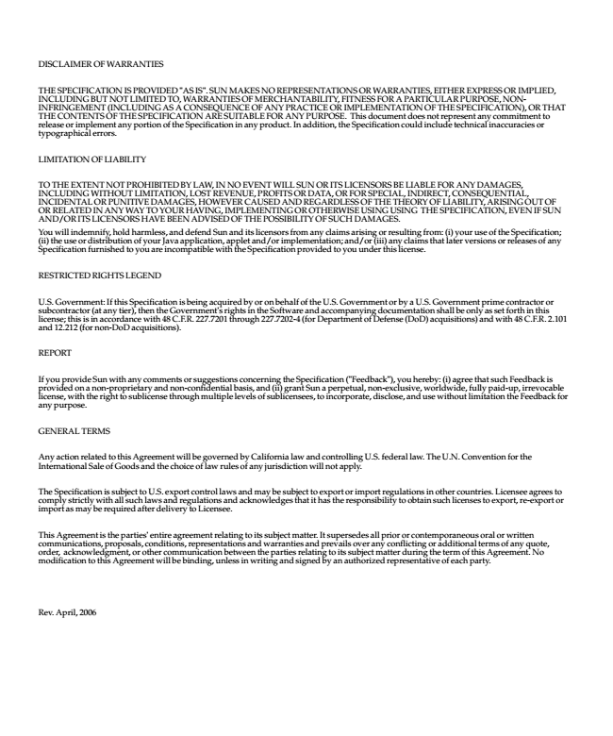

DISCLAIMER OF WARRANTIES

THE SPECIFICATION IS PROVIDED "AS IS". SUN MAKES NO REPRESENTATIONS OR WARRANTIES, EITHER EXPRESS OR IMPLIED, INCLUDING BUT NOT LIMITED TO, WARRANTIES OF MERCHANTABILITY, FITNESS FOR A PARTICULAR PURPOSE, NON- INFRINGEMENT (INCLUDING AS A CONSEQUENCE OF ANY PRACTICE OR IMPLEMENTATION OF THE SPECIFICATION), OR THAT THE CONTENTS OF THE SPECIFICATION ARE SUITABLE FOR ANY PURPOSE. This document does not represent any commitment to release or implement any portion of the Specification in any product. In addition, the Specification could include technical inaccuracies or typographical errors.

LIMITATION OF LIABILITY

TO THE EXTENT NOT PROHIBITED BY LAW, IN NO EVENT WILL SUN OR ITS LICENSORS BE LIABLE FOR ANY DAMAGES, INCLUDING WITHOUT LIMITATION, LOST REVENUE, PROFITS OR DATA, OR FOR SPECIAL, INDIRECT, CONSEQUENTIAL, INCIDENTAL OR PUNITIVE DAMAGES, HOWEVER CAUSED AND REGARDLESS OF THE THEORY OF LIABILITY, ARISING OUT OF OR RELATED IN ANY WAY TO YOUR HAVING, IMPLEMENTING OR OTHERWISE USING USING THE SPECIFICATION, EVEN IF SUN AND/OR ITS LICENSORS HAVE BEEN ADVISED OF THE POSSIBILITY OF SUCH DAMAGES. You will indemnify, hold harmless, and defend Sun and its licensors from any claims arising or resulting from: (i) your use of the Specification; (ii) the use or distribution of your Java application, applet and/or implementation; and/or (iii) any claims that later versions or releases of any Specification furnished to you are incompatible with the Specification provided to you under this license.

RESTRICTED RIGHTS LEGEND

U.S. Government: If this Specification is being acquired by or on behalf of the U.S. Government or by a U.S. Government prime contractor or subcontractor (at any tier), then the Government's rights in the Software and accompanying documentation shall be only as set forth in this license; this is in accordance with 48 C.F.R. 227.7201 through 227.7202-4 (for Department of Defense (DoD) acquisitions) and with 48 C.F.R. 2.101 and 12.212 (for non-DoD acquisitions).

REPORT

If you provide Sun with any comments or suggestions concerning the Specification ("Feedback"), you hereby: (i) agree that such Feedback is provided on a non-proprietary and non-confidential basis, and (ii) grant Sun a perpetual, non-exclusive, worldwide, fully paid-up, irrevocable license, with the right to sublicense through multiple levels of sublicensees, to incorporate, disclose, and use without limitation the Feedback for any purpose.

GENERAL TERMS

Any action related to this Agreement will be governed by California law and controlling U.S. federal law. The U.N. Convention for the International Sale of Goods and the choice of law rules of any jurisdiction will not apply.

The Specification is subject to U.S. export control laws and may be subject to export or import regulations in other countries. Licensee agrees to comply strictly with all such laws and regulations and acknowledges that it has the responsibility to obtain such licenses to export, re-export or import as may be required after delivery to Licensee.

This Agreement is the parties' entire agreement relating to its subject matter. It supersedes all prior or contemporaneous oral or written communications, proposals, conditions, representations and warranties and prevails over any conflicting or additional terms of any quote, order, acknowledgment, or other communication between the parties relating to its subject matter during the term of this Agreement. No modification to this Agreement will be binding, unless in writing and signed by an authorized representative of each party.

Rev. April, 2006



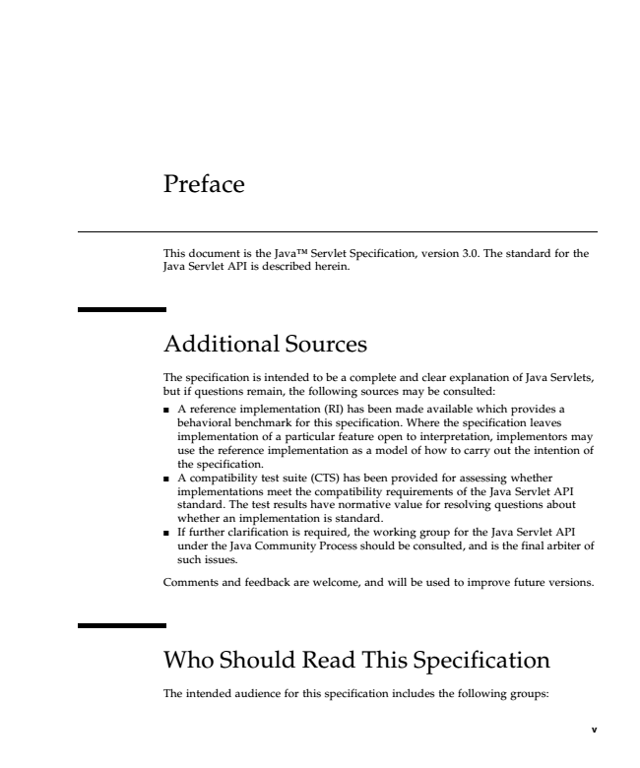

Preface

This document is the JavaTM Servlet Specification, version 3.0. The standard for the Java Servlet API is described herein.

Additional Sources

The specification is intended to be a complete and clear explanation of Java Servlets, but if questions remain, the following sources may be consulted:

■

A reference implementation (RI) has been made available which provides a behavioral benchmark for this specification. Where the specification leaves implementation of a particular feature open to interpretation, implementors may use the reference implementation as a model of how to carry out the intention of the specification.

■

A compatibility test suite (CTS) has been provided for assessing whether implementations meet the compatibility requirements of the Java Servlet API standard. The test results have normative value for resolving questions about whether an implementation is standard.

■

If further clarification is required, the working group for the Java Servlet API under the Java Community Process should be consulted, and is the final arbiter of such issues.

Comments and feedback are welcome, and will be used to improve future versions.

Who Should Read This Specification

The intended audience for this specification includes the following groups:

**v**

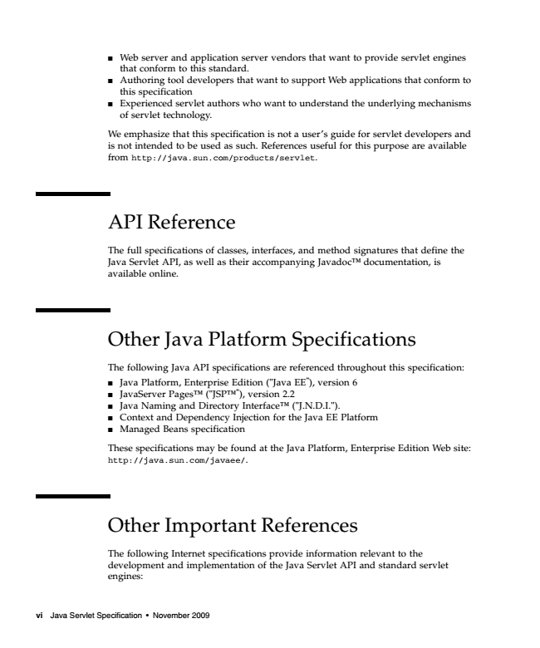

Web ■

server and application server vendors that want to provide servlet engines that conform to this standard.

■

Authoring tool developers that want to support Web applications that conform to this specification

■

Experienced servlet authors who want to understand the underlying mechanisms of servlet technology.

We emphasize that this specification is not a user’s guide for servlet developers and is not intended to be used as such. References useful for this purpose are available from http://java.sun.com/products/servlet.

API Reference

The full specifications of classes, interfaces, and method signatures that define the Java Servlet API, as well as their accompanying JavadocTM documentation, is available online.

Other Java Platform Specifications

The following Java API specifications are referenced throughout this specification:

■

Java Platform, Enterprise Edition ("Java EE"), version 6

■

JavaServer PagesTM ("JSPTM"), version 2.2

■

Java Naming and Directory InterfaceTM ("J.N.D.I.").

■

Context and Dependency Injection for the Java EE Platform

■

Managed Beans specification

These specifications may be found at the Java Platform, Enterprise Edition Web site: http://java.sun.com/javaee/.

Other Important References

The following Internet specifications provide information relevant to the development and implementation of the Java Servlet API and standard servlet engines:

vi Java Servlet Specification • November 2009

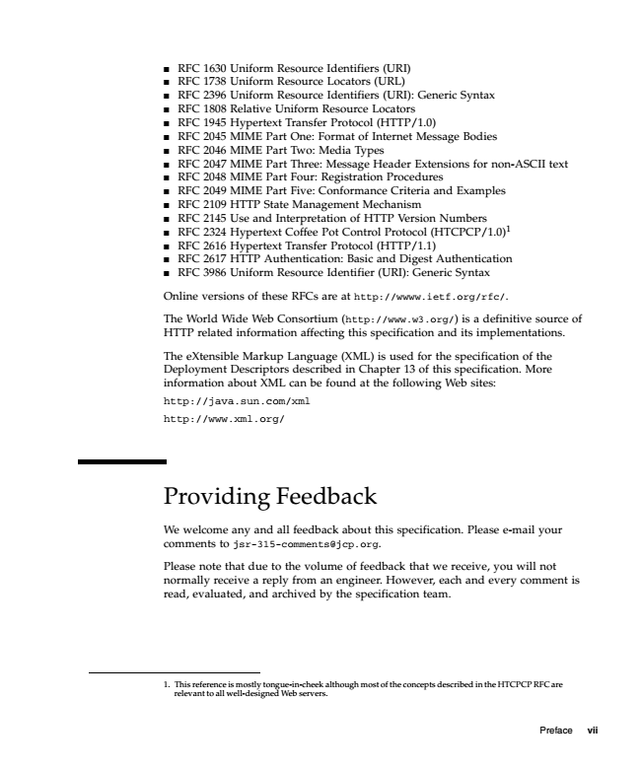

RFC ■

1630 Uniform Resource Identifiers (URI)

■

RFC 1738 Uniform Resource Locators (URL)

■

RFC 2396 Uniform Resource Identifiers (URI): Generic Syntax

■

RFC 1808 Relative Uniform Resource Locators

■

RFC 1945 Hypertext Transfer Protocol (HTTP/1.0)

■

RFC 2045 MIME Part One: Format of Internet Message Bodies

■

RFC 2046 MIME Part Two: Media Types

■

RFC 2047 MIME Part Three: Message Header Extensions for non-ASCII text

■

RFC 2048 MIME Part Four: Registration Procedures

■

RFC 2049 MIME Part Five: Conformance Criteria and Examples

■

RFC 2109 HTTP State Management Mechanism

■

RFC 2145 Use and Interpretation of HTTP Version Numbers

■

RFC 2324 Hypertext Coffee Pot Control Protocol (HTCPCP/1.0)1

■

RFC 2616 Hypertext Transfer Protocol (HTTP/1.1)

■

RFC 2617 HTTP Authentication: Basic and Digest Authentication

■

RFC 3986 Uniform Resource Identifier (URI): Generic Syntax

Online versions of these RFCs are at http://wwww.ietf.org/rfc/.

The World Wide Web Consortium (http://www.w3.org/) is a definitive source of HTTP related information affecting this specification and its implementations.

The eXtensible Markup Language (XML) is used for the specification of the Deployment Descriptors described in Chapter 13 of this specification. More information about XML can be found at the following Web sites:

http://java.sun.com/xml

http://www.xml.org/

Providing Feedback

We welcome any and all feedback about this specification. Please e-mail your comments to jsr-315-comments@jcp.org.

Please note that due to the volume of feedback that we receive, you will not normally receive a reply from an engineer. However, each and every comment is read, evaluated, and archived by the specification team.

1. This reference is mostly tongue-in-cheek although most of the concepts described in the HTCPCP RFC are

relevant to all well-designed Web servers.

Preface vii

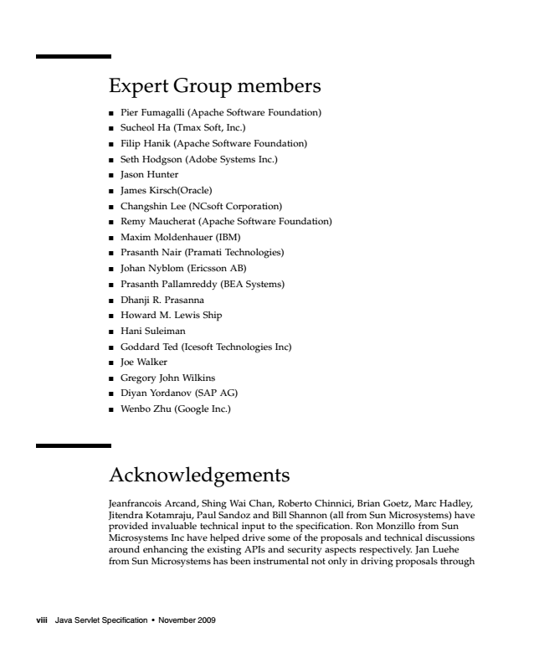

Expert Group members

■

Pier Fumagalli (Apache Software Foundation)

■

Sucheol Ha (Tmax Soft, Inc.)

■

Filip Hanik (Apache Software Foundation)

■

Seth Hodgson (Adobe Systems Inc.)

■

Jason Hunter

■

James Kirsch(Oracle)

■

Changshin Lee (NCsoft Corporation)

■

Remy Maucherat (Apache Software Foundation)

■

Maxim Moldenhauer (IBM)

■

Prasanth Nair (Pramati Technologies)

■

Johan Nyblom (Ericsson AB)

■

Prasanth Pallamreddy (BEA Systems)

■

Dhanji R. Prasanna

■

Howard M. Lewis Ship

■

Hani Suleiman

■

Goddard Ted (Icesoft Technologies Inc)

■

Joe Walker

■

Gregory John Wilkins

■

Diyan Yordanov (SAP AG)

■

Wenbo Zhu (Google Inc.)

Acknowledgements

Jeanfrancois Arcand, Shing Wai Chan, Roberto Chinnici, Brian Goetz, Marc Hadley, Jitendra Kotamraju, Paul Sandoz and Bill Shannon (all from Sun Microsystems) have provided invaluable technical input to the specification. Ron Monzillo from Sun Microsystems Inc have helped drive some of the proposals and technical discussions around enhancing the existing APIs and security aspects respectively. Jan Luehe from Sun Microsystems has been instrumental not only in driving proposals through

viii Java Servlet Specification • November 2009

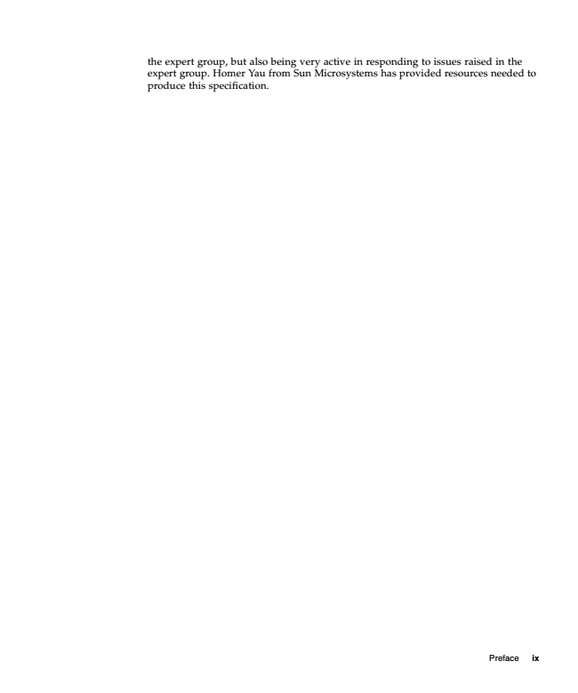

the expert group, but also being very active in responding to issues raised in the expert group. Homer Yau from Sun Microsystems has provided resources needed to produce this specification.

Preface ix



x Java Servlet Specification • November 2009